|  |
| --- |
|  |
| Puzzle Game |
|  |

|  |
| --- |
| 8/8/2020 |

# Overview:

The puzzle developed in this project is a simple game which consists of 3 x 3 grid (containing 9 squares). This game allows users to shift the squares to different positions and also it enables to display the numbers in goal state.

# Class Description:

## PuzzleClass:

The PuzzleClass class is basically the model class. It contains all the data related logic with definition of all the fields as properties. It would create 3x3 matric containing 1 to 8 digits and 0(indicates the free space). Once the number will be arrange in sequence then player will win the game.

**startGame ():**

**startGame**() is a public method of the **PuzzleClass** that contain all the logics .It would create 3x3 matric containing 1 to 8 digits and 0(indicates the free space).

## Instruction:

Instruction class is responsible for showing the instruction to the player so he/she get better idea how to play the game

This method is written for displaying the instruction to the player.

**ShowInstruction ()**

Whenever this method invoke it will bring the list of instruction and display them on the screen

## WelcomeClass:

Welcome class act like a menu where I am creating the instance of the **PuzzleClass** and **Instruction** class and display option to the player to select .on the basis of player’s selection performing the required operation

**showMenu ()**

Here greeting message is appearing on the top and list of options are appearing.

1) Start Game.  
2) Read Instruction.  
3) Exit Game.

## Use cases:

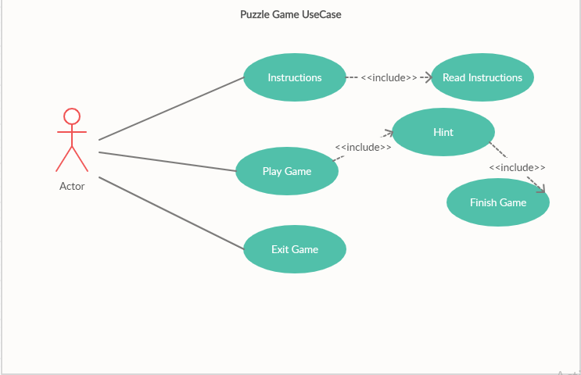

## Class Structure:

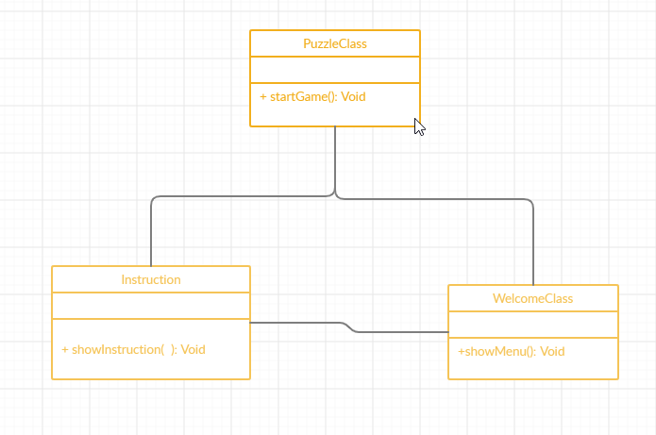

## Activity Diagram:

## 

**Flow Chart:**

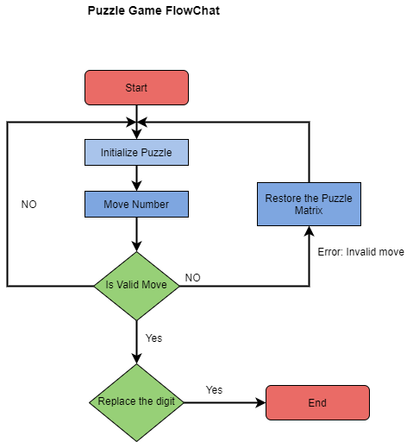

In the flowchart above, there is an initial state from which the puzzle begins. At the beginning of the game, a 3x3 matrix with the unsorted numbers will be displayed. If the user replaces the number, the validity of the trip will be verified. The system rearranges the numbers and redisplays the rearranged 3x3 matrix. If the move is invalid, the system triggers an "invalid move" error and no action is taken this time.